5G SECURITY

Prof. Anupama Bhalerao
Designation professor Department of Computer
Engineering JSPM PUNE
asb.scos@jspmuni.ac.in
Mr. Avishar Bhilare
Department of Computer Engineering
JSPM PUNE
avisharkhilare12@gmail.com

------------------------------------------------------------------------------------------------------------
Abstract: 5G will provide broadband access everywhere, entertain higher user mobility, and enable connectivity of massive number of devices (e.g. Internet of Things (IoT)) in an ultrareliable and affordable way. The main technological enablers such as cloud computing, Software Defined Networking (SDN) and Network Function Virtualization (NFV) are maturing towards their use in 5G. However, there are pressing security challenges in these technologies besides the growing concerns for user privacy. In this paper, we provide an overview of the security challenges in these technologies and the issues of privacy in 5G. Furthermore, we present security solutions to these challenges and future directions for secure 5G systems.
------------------------------------------------------$\text{∴∴∴}$--------------------------------------------------

- INTRODUCTION
The deployment of 5G networks marks a critical milestone in wireless communication, offering high-speed data transfer, increased bandwidth, and support for a multitude of connected devices. While these features pave the way for innovations such as., autonomous vehicles, telemedicine, and smart manufacturing, they also introduce a new set of security challenges. Unlike its predecessors, 5G networks are highly software-driven, decentralized, and support a much wider range of devices, making them more susceptible to various cyber threats. Securing 5G networks is crucial not only for consumer privacy but also for national security and critical infrastructure protection. This paper seeks to highlight the core security concerns surrounding 5G technology, the vulnerabilities in its design, and strategies for strengthening its security posture.
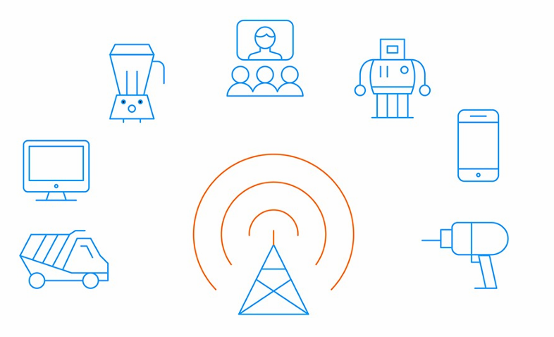
- OVERVIEW OF 5G NETWORK ARCHITECTURE
The 3GPP standards behind 5G network architecture were introduced by the 3rd Generation Partnership Project (3GPP), the organization that develops international standards for all mobile communications. The International Telecommunications Union (ITU) and its partners define the requirements and timeline for mobile communication systems, defining a new generation approximately every decade. The 3GPP develops specifications for those requirements in a series of releases.
The “G” in 5G stands for “generation.” 5G technology architecture presents significant advances beyond 4G LTE (long-term evolution) technology, which comes on the heels of 3G and 2G. As we describe in our related resource, The Journey to 5G, there is always a time period during which multiple network generations exist at once. Like its predecessors, 5G must co-exist with previous networks for two important reasons:
- Developing and deploying new network technologies takes an enormous amount of time, investment and collaboration of major entities and carriers.
- 2. Early adopters will always want to get their hands on new technologies as quickly as possible, whereas those who have made major investments in large deployments with existing network technologies, such as 2G, 3G and 4G LTE, want to make use of those investments for as long as possible, and certainly until the new network is fully viable. (Note that 2G and 3G networks are being sunset to make room for 5G deployment. See our blog post 2G, 3G, 4G Network Shut down Updates.)
The network architecture of 5g mobile technology improves vastly upon past architectures. Large cell-dense networks enable massive leaps in performance. And in addition, the architecture of 5G networks offers better security compared to today's 4G LTE net works
In summary, 5G technology offers three principle advantages:
- Faster data transmission speed, up to multi-Gigabit/s speeds.
- Greater capacity, fueling a massive amount of IoT devices per square kilometer.
- Lower latency, down to single-digit milliseconds, which is critically important in applications such as connected vehicles in ITS applications and autonomous vehicles, where near instantaneous response is necessary.
Does this mean that 5G is fully ready today? And does it mean 5G architecture is right for all applications? Read on to see how the new technology supports key applications, and which applications are more suited to 4G LTE

- SECURITY CHALLENGES IN 5G NETWORKS
- Increased Attack Surface 5G networks introduce an increased attack surface due to the higher number of connected devices, ranging from smartphones to critical IoT sensors. Many of these de vices, particularly IoT devices, are vulnerable due to inadequate security features. At tackers could exploit these devices to launch Distributed Denial of Service (DDoS) at tacks or gain access to the broader network.
- Supply Chain Vulnerabilities 5G networks rely heavily on third-party hardware and software vendors, which opens up risks of supply chain attacks. For instance, compromising a vendor’s hardware could allow malicious actors to insert backdoors or malware into the network, compromising both data integrity and national security.
- Virtualization and Cloud Security The virtualization technologies that underpin 5G, such as SDN and NFV, bring new security challenges. Virtualized functions may be susceptible to attacks, including hypervisor vulnerabilities and data leakage between virtual machines (VMs). Cloud-native architectures also raise concerns about data privacy and the potential for breaches if cloud services are compromised.
- Network Slicing Security Network slicing allows operators to partition a single physical network into multiple virtual networks, each with its own resources and characteristics. However, a security 5G Security 5 f law in one slice could potentially compromise other slices. Ensuring isolation between slices is a critical challenge in maintaining the security of 5G networks.
- End-to-End Encryption Issues While encryption is vital to 5G security, ensuring end-to-end encryption across a complex, decentralized architecture is challenging. Data may traverse multiple networks, each with varying security policies, and maintaining consistent encryption standards can be difficult.
- Edge Computing Vulnerabilities 5G networks push data processing closer to the edge of the network to reduce latency. While edge computing improves performance, it also introduces new security concerns, as edge devices and nodes are more exposed and harder to secure than centralized data centers
- MITIGATION STRATEGIES FOR 5G SECURITY
- Improved Encryption Protocols To mitigate the risks posed by 5G’s decentralized nature, robust encryption protocols are essential. This includes securing data both in transit and at rest, as well as adopting quantum-resistant cryptographic algorithms to prepare for future quantum computing threats.
- Secure Network Slicing Operators must ensure strict isolation between network slices, using technologies like hypervisors and secure software-defined perimeters. Enhanced access control measures and real-time monitoring of slice activities are also crucial for preventing cross-slice attacks.
- Strengthening Supply Chain Security Governments and industries must collaborate to establish stringent security standards for 5G hardware and software vendors. This includes performing rigorous security audits and adopting a zero-trust model for all third-party components used in the network.
- AI and Machine Learning for Threat Detection Leveraging AI and machine learning can enhance real-time threat detection in 5G networks. These technologies can analyze vast amounts of data, detect anomalies, and respond to potential attacks more effectively than traditional security systems.
- Edge Computing Security Framework To secure edge computing environments, 5G providers should implement stronger authentication methods and encrypt data at the edge. Additionally, deploying intrusion detection and prevention systems (IDPS) closer to the edge can help mitigate localized threats.
- Collaboration and Regulatory Frameworks Governments, industries, and academia must collaborate to establish global security standards for 5G networks. Regulatory bodies should enforce mandatory security practices, such as secure network design, data privacy regulations, and mandatory incident reporting.
- CASE STUDIES
- The SolarWinds Hack and Its Implications for 5G The SolarWinds attack, where hackers exploited supply chain vulnerabilities, high lights the importance of securing third-party vendors in 5G ecosystems. This case demonstrates the potential for nation-state actors to compromise critical infrastructure through insecure supply chains.
- DDoS Attack on Mirai Botnet The Mirai botnet, which leveraged IoT devices to launch a large-scale DDoS attack, illustrates the dangers of unsecured devices within 5G networks. As 5G expands the IoT landscape, similar attacks may become more common unless stringent security measures are adopted.
- CONCLUSION

5G technology holds immense promise for advancing global connectivity and enabling new applications, from smart cities to autonomous vehicles. However, its success depends heavily on the security of its underlying infrastructure. The unique features of 5G, such as network slicing, edge computing, and virtualization, present significant security challenges that must be addressed.
By adopting comprehensive encryption protocols, securing network slices, leveraging AI for threat detection, and strengthening supply chain security, stakeholders can mitigate the risks associated with 5G. Collaboration between governments, industries, and academic institutions will be crucial in establishing robust security standards that safeguard the next generation of wireless networks.
- REFERENCES
[1] "5G Security: Enabling a Secure 5G Future", GSMA, 2020.
[2] M. Labib, "Security Challenges of 5G Networks", IEEE Communications Magazine, 2019.
[3] L. Xu, "Network Slicing Security in 5G: Challenges and Solutions", Future Generation Computer Systems, 2021.
[4] "Cybersecurity in 5G Networks", European Union Agency for Cybersecurity (ENISA), 2021.
[5] “ChatGPT, MetaAI, Apple Intelligence

